CMTH642 - Assignment #2

Mohammed Amir

November 26, 2016

# Read the csv files in the folder

USDAClean <- read.csv(file="D:/Big Data/CMTH642 - DATA ANALYTICS ADVANCED METHODS/ASSIGNMENT 2/USDAClean_MohammedAmir.csv",head=TRUE,sep=",")

# 1. Create a visualization to illustrate the distribution of values for Total Fat, Protein and Carbohydrate. (12 p)

TotalFat <- USDAClean$TotalFat  
Protein <- USDAClean$Protein  
Carbohydrate <- USDAClean$Carbohydrate  
  
layout(matrix(c(1,1,2,3), 2, 2, byrow = TRUE))  
hist(TotalFat)  
hist(Protein)  
hist(Carbohydrate)

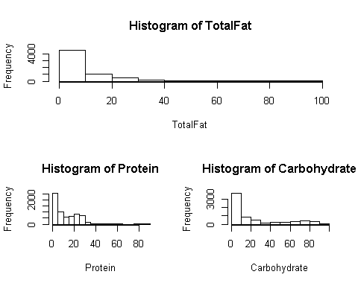

# 2. Create a visualization to illustrate the relationship between a food's Total Fat content and its calorie content. (12 p)

# Based on the graphy below the relationship between Calories and Total Fat shows that, with lower total fat, the calories value concentration is high and as the total fat value increases the calories concentration starts to get less.  
  
Calories <- USDAClean$Calories  
plot (TotalFat, Calories, col = c("green", "red"), xlab="TotalFat", ylab="Calories", main="Total Fat vs Calories realtionship graphy")  
legend("topright", legend=c("TotalFat", "Calories"), col=c("green", "red"), lty=1:2, cex=1, box.lty=0)

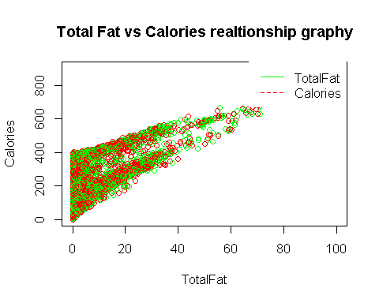

# 3. Create a logistic regression model, using High Calories as the dependent variable, and Carbohydrate, Protein, Total Fat and Sodium as independent variables. (18 p)

Sodium <- USDAClean$Sodium  
logreg_model <- glm (HighCalories ~ Carbohydrate + Protein + TotalFat + Sodium, data=USDAClean, family = binomial, )

## Warning: glm.fit: fitted probabilities numerically 0 or 1 occurred

summary(logreg_model)

##   
## Call:  
## glm(formula = HighCalories ~ Carbohydrate + Protein + TotalFat +   
## Sodium, family = binomial, data = USDAClean)  
##   
## Deviance Residuals:   
## Min 1Q Median 3Q Max   
## -5.0892 -0.0401 -0.0030 0.0088 5.4038   
##   
## Coefficients:  
## Estimate Std. Error z value Pr(>|z|)   
## (Intercept) -1.450e+01 6.689e-01 -21.67 <2e-16 ***  
## Carbohydrate 2.475e-01 1.135e-02 21.82 <2e-16 ***  
## Protein 2.383e-01 1.541e-02 15.46 <2e-16 ***  
## TotalFat 6.722e-01 2.857e-02 23.53 <2e-16 ***  
## Sodium -2.848e-04 3.031e-04 -0.94 0.347   
## ---  
## Signif. codes: 0 '***' 0.001 '**' 0.01 '*' 0.05 '.' 0.1 ' ' 1  
##   
## (Dispersion parameter for binomial family taken to be 1)  
##   
## Null deviance: 8971.1 on 6612 degrees of freedom  
## Residual deviance: 1196.0 on 6608 degrees of freedom  
## AIC: 1206  
##   
## Number of Fisher Scoring iterations: 9

# 4. Which independent variable is not significant? (10 p)

# As per the logistic regression value Sodium is not significant because it is p value of 0.347 is greater than 0.05 and has no star rating associated to it.

# 5. Which independent variable has the strongest positive predictive power in the model? (10 p)

# Based on the highest coefficient number of TotalFat, it has the highest positive predictive value

# 6. Create a script for a HealthCheck function to detect unhealthy foods. (18 p)

HealthCheck <- function(sodium, sugar, fat)  
{  
 if(sodium == 0)  
 {  
 print ("1")  
 }  
 else  
 {  
 if(sugar == 0 && sodium == 1)  
 {  
 print ("1")   
 }  
 else  
 {  
 if(fat == 0 && sugar == 1 && sodium == 1)  
 {  
 print ("1")   
 }  
 else  
 {  
 print ("0")  
 }  
   
 }  
 }  
 }

# 7. Add a new column called HealthCheck to the USDAclean data frame using the output of the function. (10 p)

# 8. How many foods in the USDAcle an data frame fail the HealthCheck? (10 p)

# 512 foods have failed the health check test were as 6101 foods have passed the test.  
  
table(USDAClean$HealthCheck)

##   
## 0 1   
## 512 6101

#head(USDAClean)  
#write.csv(USDAClean, file = "D:/USDA_3.csv", row.names= TRUE)  
#USDAClean$HealthCheck